Migrant Community Breakfast Club (MCBC) Report
Supporting Unpaid Carers in Migrant Communities

1. Introduction
In October 2024, Redbridge Carers Support Service (RCSS) received a grant from Healthwatch to deliver a targeted project aimed at identifying and supporting unpaid carers within refugee, asylum-seeking, and migrant communities.
The Migrant Community Breakfast Club (MCBC) was developed to address the complex challenges faced by migrant carers. These include language barriers, limited education, insecure housing, caring responsibilities among young people (aged 16–30), low awareness of rights, isolation, homelessness, low confidence and self-esteem, and pressures faced by single parent carers. These challenges are further compounded by systemic inequalities.
The project focuses on identifying “hidden carers,” improving access to health and social care services, and raising awareness of health inequalities. The MCBC provides a safe and welcoming environment where carers meet over a light breakfast to practise conversational English and participate in therapeutic activities such as arts and crafts to promote wellbeing.

Social Isolation Among Migrants and Carers (UK Context)
Key Statistics
- Around 1 in 3 migrants in the UK report experiencing loneliness or social isolation, particularly in their first few years after arrival.
- Migrants with limited English proficiency are significantly more likely to experience isolation, as language barriers restrict social interaction and access to services.
- Research by British Red Cross found that refugees and asylum seekers frequently experience extreme isolation, especially when placed in temporary or dispersal housing away from established communities.
- According to Carers UK, unpaid carers are already at high risk of isolation, with many reporting reduced social contact due to their caring role. This risk is further intensified for migrant carers.
- A study by The King’s Fund highlights that social isolation is strongly linked to poor mental health, increased anxiety, and depression, particularly among vulnerable groups such as migrants.

2. About the Project
Over the six-month project period, RCSS successfully identified and registered 18 hidden carers from migrant and refugee communities.
Engagement with this cohort required a more intensive, relationship-based approach compared to general carers. Building trust was time-consuming but essential in encouraging participation and sustained engagement. The project prioritised:
- Creating a safe, welcoming space for connection
- Encouraging peer support and shared experiences
- Supporting conversational English and confidence building
- Providing structured activities that promote wellbeing

2.1 Demographic Profile
Ethnicity
Ethnic Group | Percentage
Asian or Asian British – Chinese | 5.88%
Asian or Asian British – Pakistani | 11.76%
Asian Other | 41.18%
Black or Black British – Caribbean | 5.88%
Other Ethnic Group | 11.76%
White – European | 23.53%

Religion
Religious Group | Percentage
Christianity | 5.56%
Islam | 83.33%
No Religion | 5.56%
Other | 5.56%

Employment Status
Status | Percentage
Employed (Part-Time) | 22.22%
Self-Employed | 5.56%
Student (Full-Time) | 11.11%
Student (Part-Time) | 5.56%
Unemployed | 55.56%

Gender | Percentage
Male | 25%
Female | 75%

Main Disability (Cared for Person) | Percentage
Arthritis | 9.09%
Mental Health | 4.55%
Physical Sensory | 9.09%
Trauma/Stress | 77.27%

3. Key Challenges Identified
3.1 Cultural and Social Barriers
- Caring is often seen as a family duty rather than a recognised role
- 83% of carers (primarily Asian communities) reported guilt in seeking external support
- Stigma around mental health and caring responsibilities
- Cultural expectations to “keep care within the family”
- Mistrust of formal services
Initially, RCSS faced distrust among migrants, particularly those who had arrived in the UK illegally. Their suspicion and fear of deportation led to a reluctance to seek assistance. Therefore, building trust with this group is crucial for providing effective support.

3.2 Immigration and Housing Issues
- Anxiety around immigration status
- Insecure or unsuitable housing
- Pressure from Jobcentre to seek employment despite caring responsibilities
- Lack of confidence to advocate for housing needs
Accommodation Type | Percentage
Home Office Accommodation | 2.08%
Temporary Accommodation | 72.92%
Unknown | 25%

3.3 Poverty and Financial Hardship
- Many carers (particularly asylum seekers) live in poverty
- Experiences of trauma, PTSD, and depression
- Limited or no recourse to public funds

A 19-year-old young carer was referred to us by Hestia Outreach. Her family had fled Albania to escape modern-day slavery and had recently been granted refugee status. She shared her experiences of caring for her mother, who lives with mental health challenges, as well as the family’s ongoing financial and housing difficulties.
Despite everything she has endured, she secured a part-time job to help support her mother and younger siblings, while also pursuing her dream of going to university. With remarkable determination, she returned to school to complete her A-levels while continuing her caring responsibilities.

Support provided included:

- Food vouchers
- Housing Support Fund applications
- Carers Trust grants
- Emotional support and counselling

3.4 Language and Information Barriers
- Limited English proficiency
- Difficulty understanding healthcare and legal systems
- Low literacy levels (in both English and first language)
- Lack of awareness of rights and available services
A newly registered carer mentioned that it was challenging to get services to acknowledge or listen to her due to her limited English proficiency. She stated that RCSS was the only service that offered her a scheduled appointment and worked with her.

3.5 Addressing Mental Health Challenges with Sensitivity
Many migrant carers reported experiencing: stress, anxiety, depression, PTS, trauma, and isolation, often linked to:
- War or conflict exposure
- Family separation
- Migration journeys
- Experiences of exploitation or violence
- Difficulties integrating into the UK
- Navigating unfamiliar systems

3.6 Trust and Engagement Barriers
- Fear of deportation among undocumented migrants
- Reluctance to engage with statutory services
- Greater engagement observed after immigration status was secured

4. Service Delivery and Support
4.1 Creating Safe and Empowering Spaces
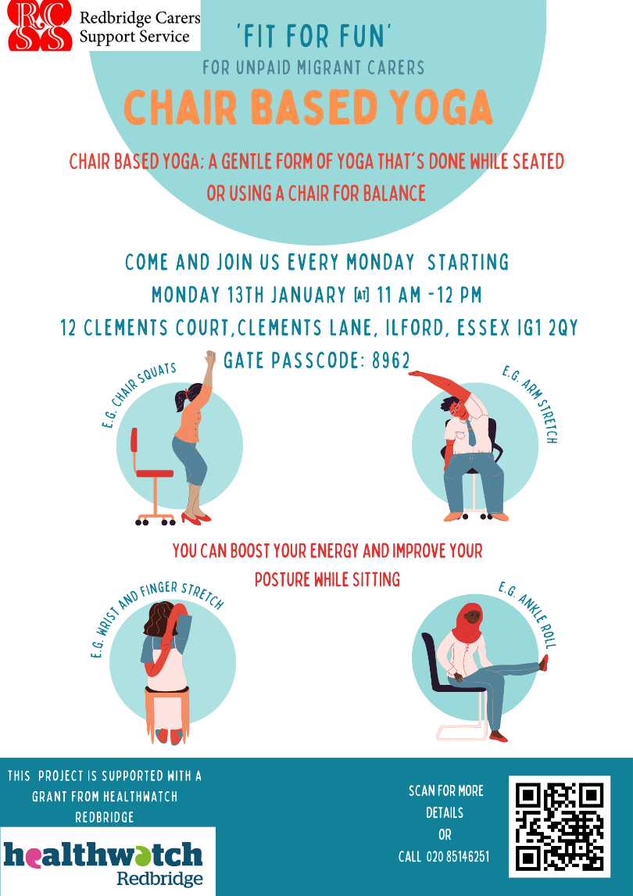
The MCBC provided:

- A judgement-free space to practise conversational English
- Peer support and shared lived experiences
- Health and wellbeing activities, including:
  - Arts and crafts
  - Chair-based yoga
  - Advice surgeries
  - Emotional wellbeing sessions

4.2 Tailored Referrals and Support during the project
Service | Engagement
Community Support Casework | Ongoing support
MCBC Group | 6 regular attendees
Counselling | 2 engaged
Health & Wellbeing Activities | 8 attended
Housing Support | Ongoing
Social Services | Supported

4.3 Mental Health Support
RCSS adopted a culturally sensitive approach:
- Peer support within group settings
- Therapeutic activities (arts, yoga)
- Informal and integrated emotional support
- Culturally aware delivery of services

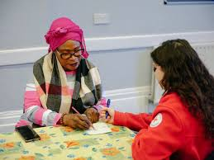
4.4 Partnership Working
RCSS collaborated with:
- British Red Cross
- Wanstead & Woodford Migrant Support
- GP services
- Asylum Support Forum
These partnerships improved referral pathways and access to culturally appropriate services.

5. Outcomes and Impact
The project enabled migrant carers to:
- Build confidence in English communication
- Reduce isolation and improve wellbeing
- Access housing, financial, and health services
- Engage in ongoing casework support
- Participate in wellbeing and respite activities
- Advocate for themselves and their families
- Develop resilience and a sense of belonging

6. Case Studies
A family of five unpaid carers, consisting of Mother, Father, and three siblings, were referred to RCSS by the British Red Cross. This referral was made by a link worker at the London Refugee Support Service, which specialises in advocacy with the Home Office, councils, and external organisations to support asylum seekers and refugees.
This family are newly recognized refugees from Iraq, fled persecution and arrived in the UK in 2020, bringing their youngest child, who was only six years old at the time and is also the cared-for individual. Two of the children, a son and a daughter, have a good command of English and can translate for the family, whose first language is Kurdish Sorani.
Since arriving in the UK, the family has faced severe hardships, particularly with unsafe and inappropriate housing provided through Home Office asylum support. They finally received refugee status in December 2023, gaining access to public funds, leave to remain, and safe temporary accommodation in Redbridge.

Case Study 1

The family from Iraq caring for a child with cerebral palsy received:
- Benefits support
- Advocacy with Jobcentre
- Emotional support
- Engagement in MCBC

Case Study 2
The Carer was referred to RCSS by Healthbridge Direct (GP Federation). She is a 20-year-old-full-time student at Westminster University, studying Cognitive Development & Neuroscience. As the primary Carer for her mother and the eldest sibling of a 17-year-old and a 12-year-old, she faces significant responsibilities. Her mother suffers from several health conditions, including a slipped disc that affects her mobility and severe depression.
The Carer has been struggling with her responsibilities and has been advocating on behalf of her mother at the Job Centre. Despite her receiving sick notes from her GP stating she is unfit for work; the Job Centre insists that her mother should actively seek employment or risk having her benefits cut.

A 20-year-old student carer supporting her mother:
- Received advocacy support with Jobcentre
- Experienced reduced stress after RCSS intervention
- Accepted counselling support

Case Study 3
The carer, a Parent Carer, self-referred to us as she cares for her son and daughter, both on the autism spectrum. Carer is a married mother of 2 and has lived illegally in the UK for the past 12 years, she has no recourse to public funds and relies on her husband, who has British status. Although she does not currently need support from our services, she has volunteered to assist with the RCSS Migrant Conversation Club project, helping carers improve their conversational English.
She has completed several online courses focused on working with SEND children and supporting asylum seekers and refugees. Since the launch of the Migrant Community Breakfast Club in October, she has been a dedicated volunteer, playing a crucial role in our social events and information forums. Additionally, she is actively involved in our monthly migrants and refugee group, where we identify hidden carers within these communities and host sessions to enhance their conversational English skills.

A parent carer with no recourse to public funds:
- Became a volunteer supporting the MCBC
- Assisted with conversational English sessions
- Requested a reference for her visa application

7. Health Inequalities and System Barriers
Key Issues Identified
- Limited access to healthcare due to immigration status
- Digital exclusion among older carers
- Language barriers in accessing services
- Difficulty navigating SEND, GP, and specialist services

Interactions with Healthcare Services
- Lack of patience and cultural understanding from some professionals
- Misinterpretation of language barriers as non-cooperation
- Carers feeling intimidated and reluctant to seek support

8. Recommendations
RCSS recommends:
- Continued funding to sustain and expand MCBC
- Use of translation tools (e.g. digital translation for forms and communication)
- Increased cultural competency training for professionals
- Accessible, multilingual information formats
- Digital skills training for migrant carers
- Greater flexibility in Jobcentre expectations for carers

9. Project Timeline and Delivery Overview
The project included:
- Weekly MCBC sessions
- Chair-based yoga programme (21 weeks)
- Workshops (ceramics, IT skills, conversational English)
- Outreach to local organisations and services
- Events and wellbeing activities (museum visits, walks, social events)

10. Conclusion
The Migrant Community Breakfast Club has demonstrated significant impact in identifying and supporting hidden carers within migrant communities. Despite the short six-month timeframe, the project has successfully built trust, increased engagement, and improved access to essential services.
RCSS has laid a strong foundation and recommends continued investment to expand this vital work and further support migrant carers in overcoming systemic barriers.

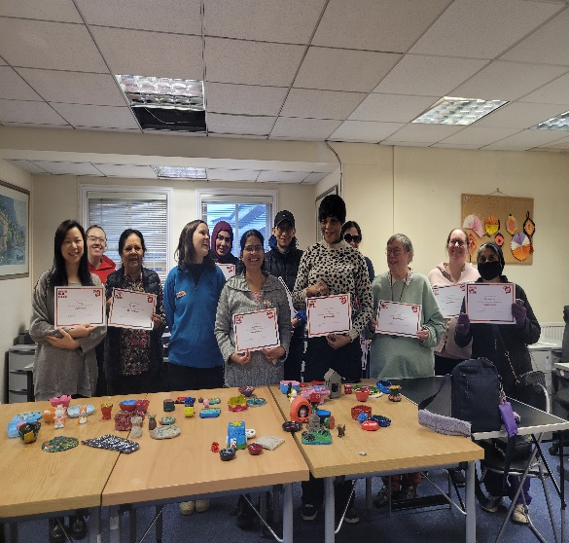 | Fit4Fun Weekly Yoga sessions ran from January ’25 for 21 weeks.  Migrant carers were able to participate in RCSS Ceramics Workshop | 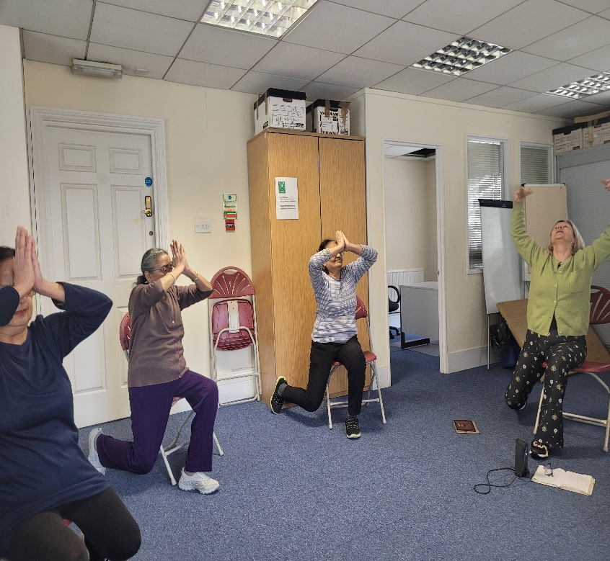

11. Acknowledgements
RCSS would like to thank:
- Healthwatch for funding the project
- British Red Cross and partner organisations for referrals
- All carers who participated and shared their experiences

Project Lead Officer: Sylvia Williams – Community Support Officer
Project Report Officer: Rani Raju – Operations Manager

