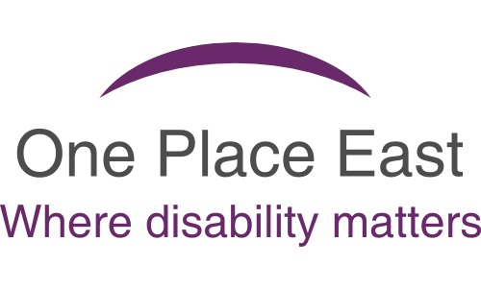
Meet new people & make friends

Speak up about your services & have your say

Would like to invite you to
One Place Voice –
Adults with Learning Disabilities
Service User Meeting

Guest Speaker
Attending
Tuesday 3rd May 2022




Service User Meeting

pm to pm
Hear About
The New Community
Hubs

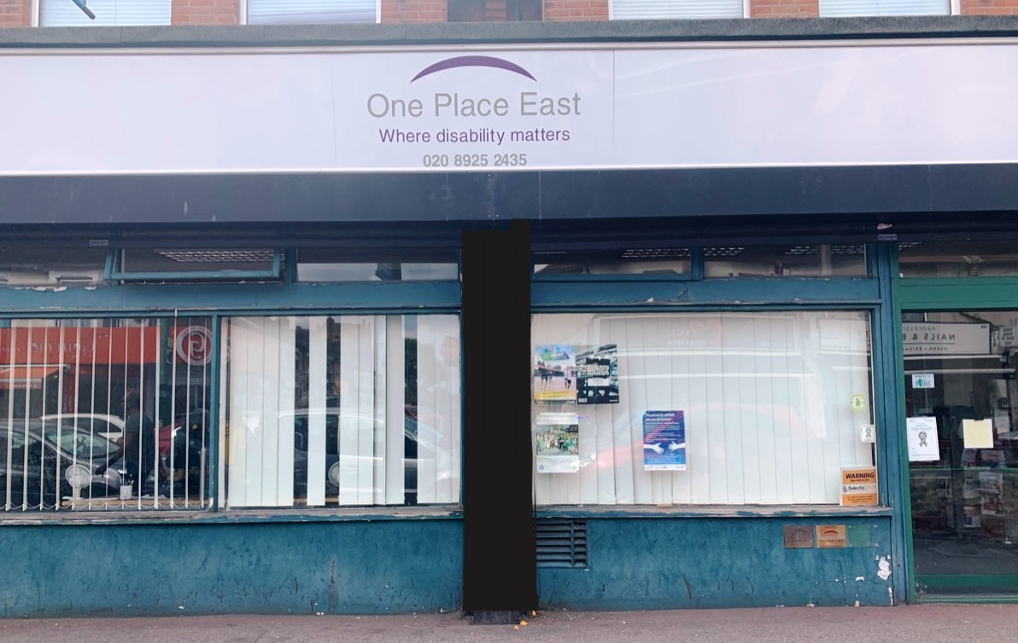
One Place East Office
98-100 Ilford Lane,
Ilford, Essex
IG1 2LD

For more information or to book your place call Carol on
020 8925 2435 / 078 1420 5741



Please turn over

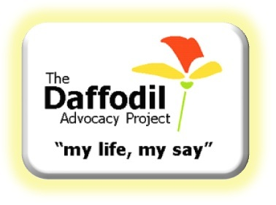
How to find us

One Place East Office
98-100 Ilford Lane
Ilford, Essex
IG1 2LD

020 8925 2435 / 078 1420 5741
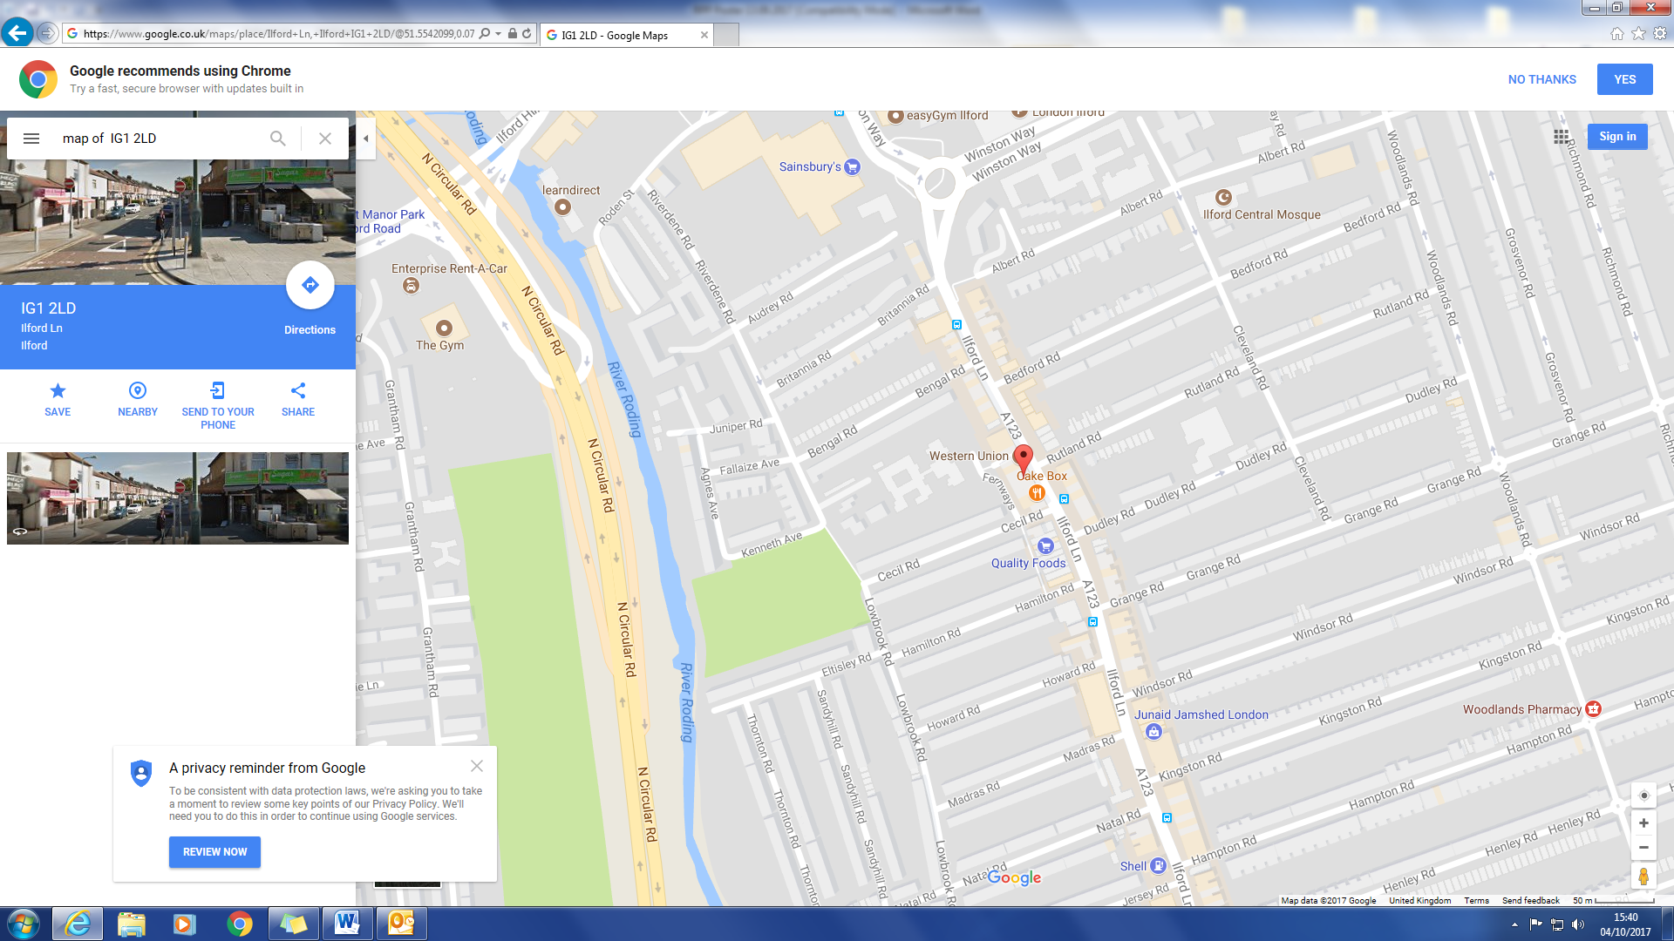

We are here


Buses 128, 150, 167, 169, 247, 275,
462 stop nearby

