


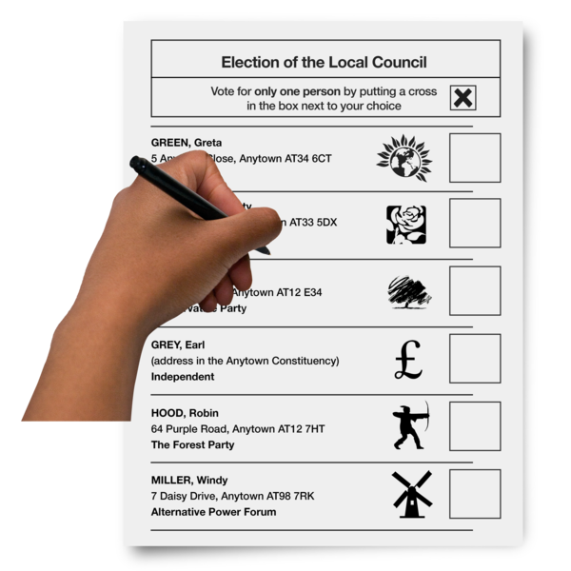
Would like to invite you to an event about
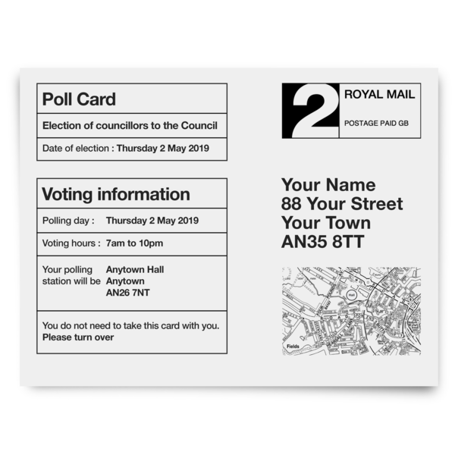

Local Council Elections 2022
Who to vote for?

Cllr Mark Santos Redbridge Labour Group attending
Tuesday 26th April 2022



Service User Meeting


pm to pm

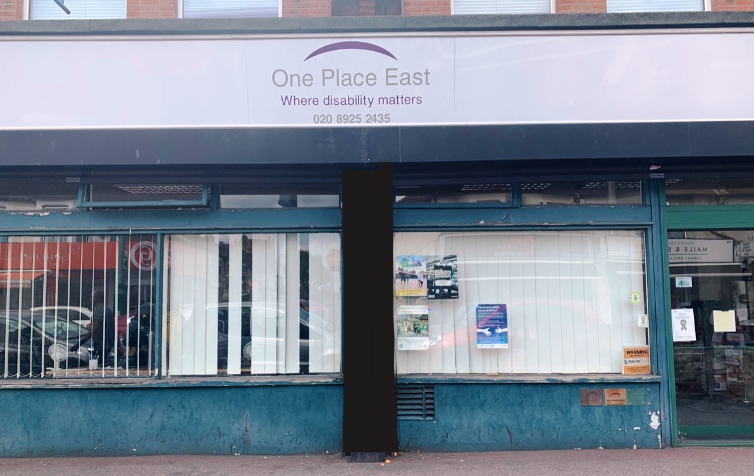
Reps from other different Political Parties to be confirmed
One Place East Office
98-100 Ilford Lane,
Ilford, Essex
IG1 2LD

For more information or to book your place
Please call the office or Carol on
020 8925 2435 / 078 1420 5741



Please turn over


How to find us

One Place East Office
98-100 Ilford Lane
Ilford, Essex
IG1 2LD

020 8925 2435 / 078 1420 5741
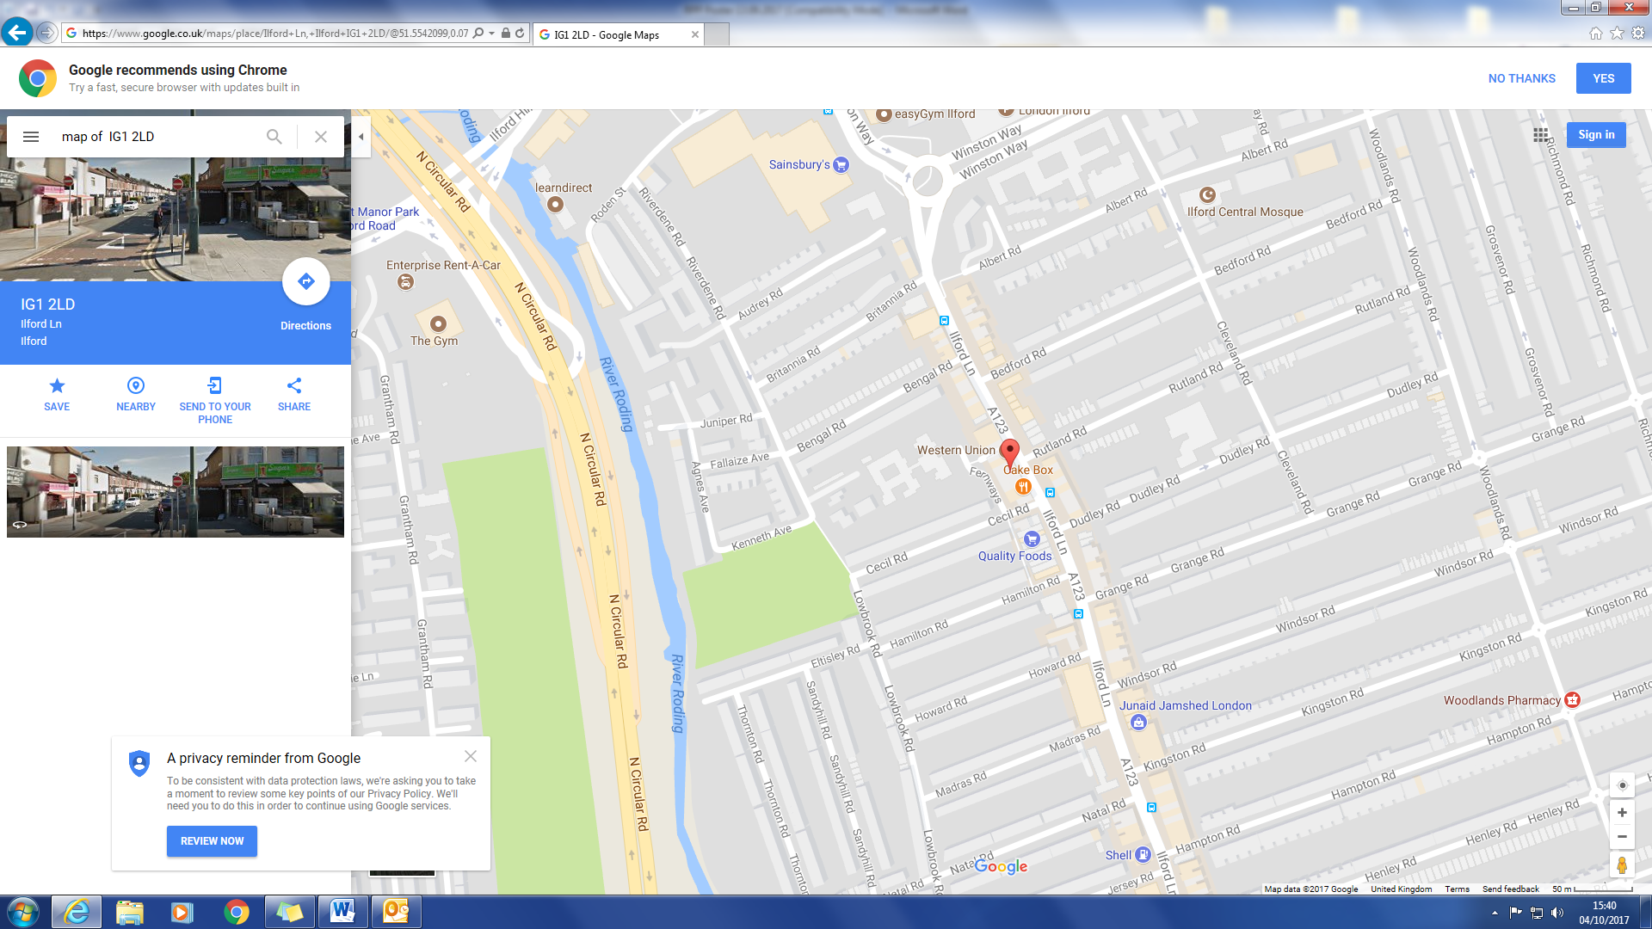

We are here


Buses 128, 150, 167, 169, 247, 275,
462 stop nearby

