A Strategic Plan for the Community Falls Prevention Service in Redbridge
2016 - 2018

Introduction
The Redbridge Interagency Community Falls Prevention Service was first developed in 2004. The service is funded jointly by Redbridge CCG and Redbridge Council. It is delivered by Age UK Redbridge, Barking and Havering (RBH).
Since 2004, the Community Falls Service has developed to include:
- management of the Falls Pathway
- exercise classes and one-to-one exercise training
- training for health and social care professionals
- information sessions for a wide variety of community and professional groups
- production of the ‘Top tips for preventing falls and slips’ handbook
- organisation of promotional events
- input into the development of policy
- Management of the Falls Working Group and the Falls Steering Group.
The service produced a three year strategy in 2008. The following updated Strategy provides proposals to further develop the integrated community falls prevention service. The Strategy is divided into the following sections:
- Section 1: The reasons for developing the community falls service
- Section 2: The aims and objectives
- Section 3: Policy and research context
- Section 4: The local picture in Redbridge
- Section 5: Current provision and the service profile
- Section 6: The identification of good practice, needs and gaps
- Section 7: Key proposals
- Section 8: Outcomes
- Section 9: Implementation
- Section 10: Conclusion

The reasons for developing the Community Falls Prevention Service
  - Why is falls prevention important?
- National priority: falls prevention is a national priority and a key public health and social care issue. It was part of the National Service Framework for Older People and is included in National Institute for Health and Care Excellence (NICE) guidelines. Whilst the trends in Strokes, TIAs and Heart Attacks are reducing, fractures resulting from falls continue to rise.
- Quality of life: both falls and the fear of falling can have a detrimental effect on the quality of life of older people, leading to a decrease in physical, psychological and social functional abilities.
- Human considerations: ‘The human cost of falling includes distress, pain, injury, loss of confidence, loss of independence and mortality. Falling also affects the family members and carers of people who fall.’ (NICE guidelines 2013).
- Financial considerations: there are costs to both the NHS and the local authority in relation to treatment, rehabilitation and support. It is estimated by the National Osteoporosis Society (2010) that falls cost the NHS and social care services £2.3 billion per year. For example:
  - Hip fractures account for approximately 20% of orthopaedic bed occupancies in the UK.
  - Social care costs are incurred for short, medium and long term care and support needs.
  - Annually ambulance services respond to 700,900 calls from older people who have fallen. This comprises ten per cent of total calls. Around a quarter do not go to hospital. (J.L.Newton et al 2006)
  - One in three people over 65 and one in two over 80 fall yearly. 40% of Nursing Home residents fall twice a year or more. (Department of Health Falls and Bone Commissioning Toolkit 2010)
  - Evidence shows that falls prevention services are cost effective and can make substantial savings (Fracture preventions Services: an economic evaluation, Dept of Health 2009)
  - Who is most at risk of falls?
- The tendency to fall increases with age. Older people (aged 65+) are not only most at risk of falling, but are also more prone to injury and complications when they do fall. The 65+ age group is one of the fastest growing sectors of the population (see 4.2 below).
- Vision impaired people are 1.7 times more likely to fall and 1.9 times more likely to have multiple falls than people with good vision (Source: ‘Falls –costs, numbers and links with visual impairment’ Tammy Boyce 2011)

Aims and objectives:
  - There are four main aims for community development work in falls prevention:
- Empowering older people to take responsibility for falls prevention
- Encouraging active healthy living
- Creating safe environments
- Raising awareness of falls prevention
  - The objective is to reduce the number of older people suffering falls and ultimately to save lives. This can only be achieved by working in partnership to further develop awareness and to ensure access to falls prevention services for all older people.

Policy and research context:
  - The National Service Framework for Older People effectively introduced a Falls Prevention programme from 2001 to 2011, which set out ‘to reduce the number of falls which result in serious injury and ensure effective treatment and rehabilitation for those who have fallen’.
  - The National Institute for Health and Clinical Excellence (NICE) issued updated guidance in 2013. Relevant NICE publications include Falls: assessment and prevention of falls in older people (2013) and The management of hip fracture in adults (2011). There are also NICE reports covering Osteoporosis. The recommendations for Falls prevention include:
- Case / risk identification
- Multifactorial falls risk assessment
- Multifactorial interventions
- Strength and balance training
- Exercise in extended care settings
- Home hazard and safety intervention
- Medication reviews
- Encouraging participation of older people in falls prevention programmes
- Education and information giving
- Issues of falls in older people during hospital stays
- The Department of Health Falls and Bone Health Commissioning Toolkit 2009 indicates a pyramid of Care. 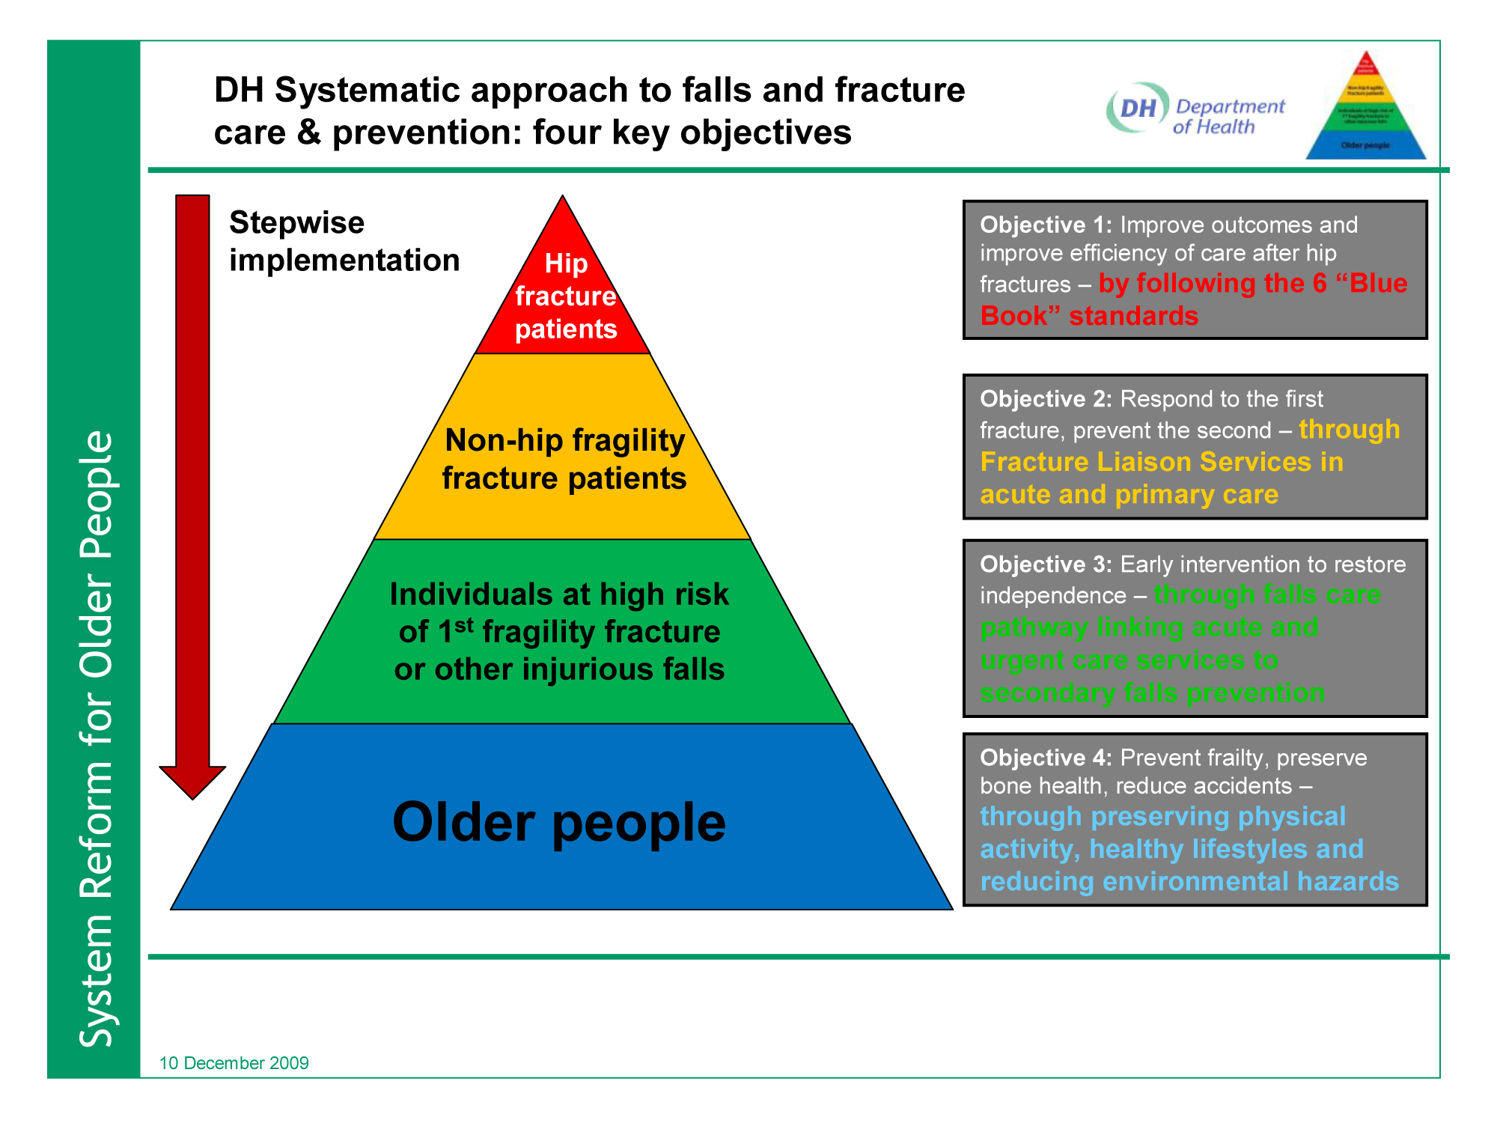
The current integrated community service focuses on the base of the pyramid aiming to prevent the move up the pyramid. However, the service also provides input at other levels of the pyramid by working with older people and professionals in the Health and Social Care arenas.

The following is an example of the changes in health and social care costs before, during and after a fall.
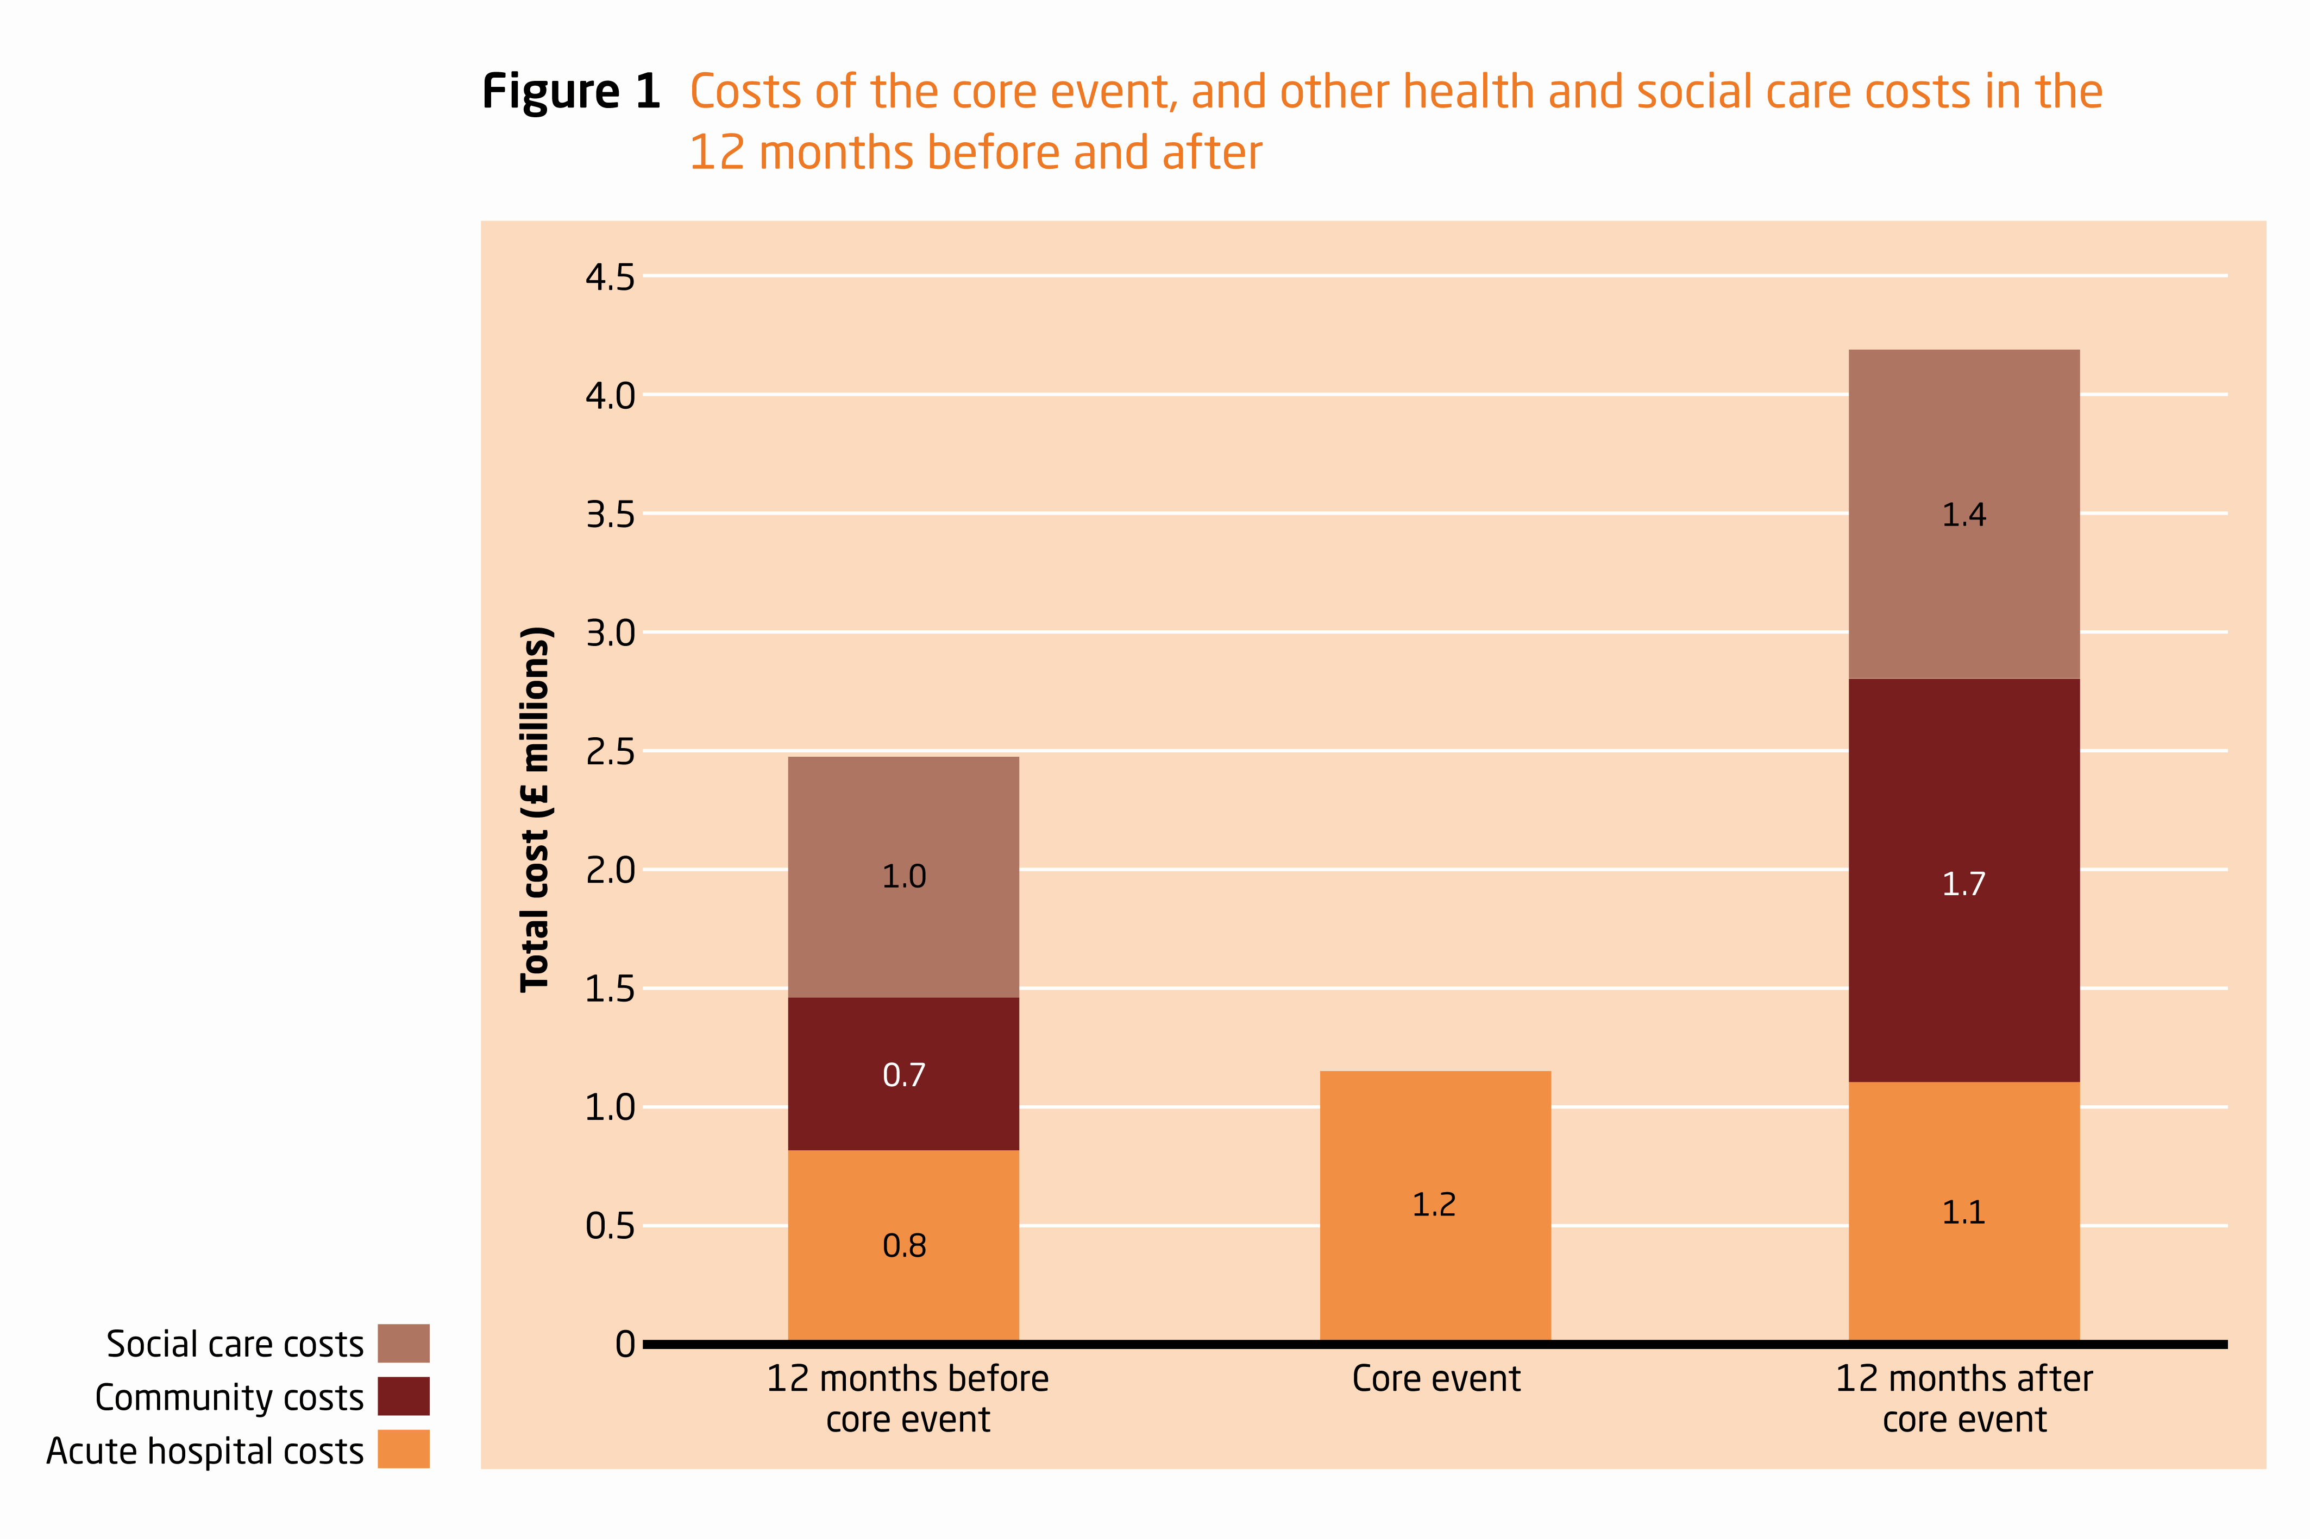
Tian, Thompson, Buck and Sonola ‘Exploring the system-wide costs of falls in older people in Torbay’ 2013

The local picture in Redbridge
  - The assessment of need in Redbridge
Falls Prevention has been addressed in two needs assessments.
- An ONEL QIPP-driven Falls Prevention needs assessment, led by Havering and covering all four ONEL boroughs was completed at the end of 2011. The assessment included a stakeholder workshop (September 2011), which recognised the strengths of the Falls Prevention Service provided by Age UK Redbridge but also identified a number of service gaps and issues.
- The Redbridge Joint Strategic Needs Assessment 2012 also includes a chapter on Falls Prevention.
  - The older population in Redbridge
- In Redbridge the total population in the 65+ age group is expected to rise by twelve per cent from 2012 to 2020, from 34,300 to 38,900 (Projecting Older People’s Population Information System: POPPI )
- POPPI also predicts that the number of people living alone in Redbridge aged 65+ will be over 9000 by 2020, rising from 8378 in 2012. Older people living alone are more likely to fall.
- The number of falls-related admissions to hospital of Redbridge residents aged 65+ is predicted to rise from 733 in 2012 to 823 in 2020.
- The number of Redbridge residents aged 65+ who will have a fall is predicted to rise from 9277 in 2012 to 10487 in 2020 (POPPI)

Current provision and the service profile
  - Current Service
- The current integrated Falls Prevention Service costs a total of £57,250 per annum. This cost is jointly shared between LBR and Redbridge CCG.
- The work programme for the service includes the following:
  - Influencing a wide range of statutory, voluntary and community sector partners to ensure all are engaged with the Falls agenda.
  - Managing the falls referral and assessment process and maintaining the falls register
  - Monitoring the falls pathway and liaising with all relevant agencies/professionals to promote its effective implementation
  - Developing and implementing the falls prevention training programme (mainly for professional health and social care staff)
  - Developing and implementing the falls awareness programme for statutory and voluntary sector organisations and for community groups
  - Organising events and supporting other events to promote knowledge about falls prevention
  - Developing and implementing the falls prevention exercise programme (this includes managing the work of the exercise instructor, the Otago programme and directly providing exercise classes)
  - Production of information and distribution to a wide audience
  - Coordinating the Falls Steering Group and the Falls Working Group, bringing together a range of professionals ensuring knowledge is shared.
  - Collecting and disseminating data relating to falls prevention
  - Contributing to strategic activity in relation to falls.
- The effectiveness of Age UK RBH’s current Falls Prevention Service in Redbridge has been recognised not only by the positive feedback received at the September 2011 Redbridge stakeholder workshop, but also by two external validations for the service. First, following a competitive process, Age UK RBH was selected by Age UK – on the basis of experience and skills in delivering effective falls prevention services – as one of seven partners across the three nations to develop and test best practice in relation to falls assessment procedures and guidance. Secondly, again following a competitive process, Age UK RBH was selected by Age UK as the sole test pilot site for a ‘Postural Stability Instructor Service for older people living in the community’. This has bought valuable funding to the borough to enable the provision of additional exercise opportunities. In addition to these two successes, the service is generally recognised as a beacon model and Age UK RBH is frequently consulted by other Falls services.

Current good practice, needs and gaps:
This section is based on the outcomes of the JSNA.
  - Current good practice
The following aspects of good practice were highlighted by the Redbridge Falls Prevention and Bone Health Workshop:
- Jointly funded service
- Established falls clinics
- Established Falls Pathway
- Developing partnerships of service providers to ensure coordinated services. The coordination of service providers, which supports improved access to all available services
- Information and awareness-raising on falls, achieved by talks, events and information leaflets that reach a wide variety of groups, individuals and professionals throughout the borough.
- Training in Care Homes, Nursing Homes and for other relevant professionals to increase awareness
- Joint working between health and social care professionals to ensure a joined up services
- Established links with other services – e.g. the Long Term Conditions Service – ensure information on falls prevention is provided to a wide range of people
- Increased physical activity opportunities for older people, achieved via a wide range of exercise opportunities provided by both the Age UK service and Vision Redbridge Culture and Leisure.
- Home hazard assessments
- Wide variety of patient forums
- Working and Steering groups
- Screening of patients
- Focus on ‘hard to reach’ groups, ensuring wide awareness of prevention issues and comprehensive provision of services
- Handyperson Scheme undertakes minor repairs and improvements to remedy potential hazards.
  - Needs, gaps and issues in general provision

Current falls prevention services, although of high quality, are not sufficient to meet the borough’s increasing needs. The POPPI forecast indicates that the number of falls in Redbridge for people aged 65+ is set to increase by 35%, from 8,943 in 2010 to 12,088 by 2030, with a predicted 28% increase in hospital admissions due to falls in the same period. Data from SUS on falls-related hospital admissions for people of all ages in Redbridge show an upward trend, suggesting that falls admissions may continue increasing if interventions are not strengthened (see Figure 1 below).
Figure 1: Falls-related admissions in Redbridge (2008/09 – 2010/11)
Red line= forecast to 2015/16

Diabetes, dementia and other limiting long term conditions/illnesses, which have a significant association with falls, are on the increase (see Figure 2 below).
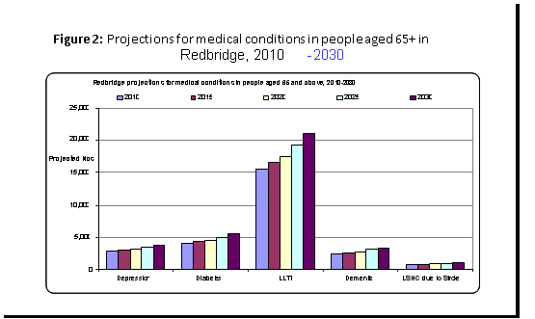

In view of the increasing incidence of conditions and illnesses which have a significant association with falls, there is a need to further develop awareness training for GPs, other professionals, patients and their carers, especially in relation to ‘hard to reach’ groups.

Hospital admissions for fractures as a result of falls in Redbridge increased from 325 in 2008/09 to 384 in 2010/11 (source: SUS). POPPI indicates a predicted increase from 7233 in 2012 to 823 in 2020 for admissions to hospital for all falls from Redbridge residents aged over 65.

Mortality from accidental falls in Redbridge increased from 79 in 2008/09 to 106 in 2010/11 (source: SUS).

The incidence of osteoporosis – which increases the risk of fracture from a fall and is the most common disease of the bone - is rising rapidly as the population ages. Estimates indicate that for people over 70 years the osteoporosis rate is 30%, while for those over 80 years it increases to 40%. There needs to be a better link between bone health services, including osteoporosis services, and falls prevention services.

There are concerns that the role of GPs and the referral routes open to them are not always clear. The current format of Level 2 Falls Assessment forms needs to be reviewed in order to address this problem.

The importance of medication reviews continues to be an issue that needs to be promoted. Lack of medication reviews is important to patients living in the community and those living in care homes.

Registers of falls and hospital admissions due to falls are not maintained at all Care Homes.

The systems for onward referral by the Ambulance Service (for fallers seen by Ambulance Service personnel but not transported to A & E) and by A & E services (for fallers who are seen in A & E but not admitted to hospital) require improvement in order to ensure that fallers access appropriate services, e.g. exercise classes, access to the Pathway and Lifeline.

Lifeline and other telecare alarm services have an important role to play in falls prevention awareness-raising and case-finding, with opportunities to develop information provision and clear referral pathways.

Strategic aims and outcomes

8.1 Strategic Aims

The Falls Service has the following strategic aims:

8.1.1 Service mapping: ensuring there is a comprehensive map of relevant Redbridge falls prevention services, with clear information about access to them.

8.1.2 Information and awareness: empowering older people and families to stay active and healthy by providing and disseminating information and by promoting services and healthy lifestyles.

8.1.3 Working with General Practices: working proactively with GP practices and Patient Participation Groups to improve awareness of falls prevention and relevant services. Resources will be concentrated on practices where available data analysis indicates the highest level of falls.

8.1.4 Falls Pathway: promoting the Falls Pathway and ensuring that its effective operation leads to full and appropriate use of the Falls Service. This will involve:
  - reviewing Level 1 and 2 assessment forms;
  - improving referral quality and follow up, and
  - improving cross-referral between services.

8.1.5 Home safety: working with partner organisations to promote home safety via home hazard assessments.

8.1.6 Engagement with other services: working with the Fire Brigade, Ambulance Services and other community providers to promote falls awareness and information, to improve referral processes and to ensure good use of the Falls Pathway.

8.1.7 Training: improving health and social care staff knowledge and awareness by including falls prevention training in induction programmes.

8.1.8 Transport: reducing the risk of falls on public transport by participating in training programmes for drivers and highlighting the needs of older people.

8.1.9 Medication: reducing the risk of falls by promoting the practice of medication reviews and encouraging pharmacy input to care homes.

8.1.10 Care Homes: reducing the risk of falls in care homes by:
  - Supporting any commissioning or care home initiatives to develop systems for collecting, analysing and monitoring statistics about falls-related admissions and falls in care homes;
  - Supporting commissioners and partner organisations in initiatives to promote falls awareness training for care home and staff and extending exercise opportunities for care home residents.

8.1.11 Bone Health: supporting health colleagues in their development of bone health work in Redbridge and improving monitoring of bone health.

8.1.12 Telecare: supporting the expansion of Telecare in falls prevention, by supporting Lifeline colleagues as they further develop the Lifeline visiting service (including in sheltered housing) and by using the Lifeline/Telecare service’s information about risk indicators as a basis for offering appropriate interventions.

8.1.13 Hospitals: supporting hospital led falls prevention initiatives wherever possible.

8.1.14 Frailty: supporting frailty programmes wherever possible.

8.1.15 Safety on the streets: work with appropriate service providers to ensure pavements and street furniture provide a safe environment to reduce the number of pavement falls.

8.2 Outcomes

Implementation of the strategic aims listed above will lead to the following outcomes:

- Older people will be empowered – via the provision of information, advice and exercise opportunities – to take responsibility for falls prevention.
- Timely and responsive early intervention and prevention services will be developed, provided and continually improved by well-informed professionals.
- Well-designed and efficient early intervention and prevention processes will be implemented consistently across health, social care, voluntary and community organisations and institutions.

Implementation:
  - See Appendix 2 for two year implementation plan.

9.2 Monitoring arrangements

These will be agreed with the Commissioners of the service but will continue to involve quarterly reporting of agreed indicators.

In Conclusion
The strategy is an ambitious one and requires commitment from a wide variety of service providers. Its successful implementation will result in an early intervention and prevention service which will enhance and promote the well-being of older people living in Redbridge and ensure that they are provided with opportunities to take action to reduce the possibility of falling. However, if they do fall they will be given appropriate support to overcome any issues arising.
Appendix 1 – Redbridge JSNA commissioning issues
The current Redbridge JSNA identifies a number of commissioning issues. The considerations relevant to the community falls service, most of which this report addresses, are as follows:
- Review and promote the falls care pathway to ensure it meets older people’s needs and that it captures all relevant services.
- Strengthen falls prevention services, particularly around:
- training of GPs and other health and social care professionals
- improving falls awareness
- extending exercise programmes
- regular medication reviews
- improving early intervention measures to promptly identify those at risk of falling.
- Develop systems to monitor falls in, and falls admissions to hospital from, care homes and ensure a register of falls and of hospital admissions due to falls is in place.
- Expand falls awareness training to people with long term conditions/illnesses, their carers and relevant staff.
- Strengthen the multi-agency Falls Steering Group, update the strategy and develop a new falls prevention action plan.
- Improve rehabilitation services for people who have lost functional ability or confidence after a fall.
- Expand Telecare services to include falls prevention, by picking up underlying trends that indicate risk of falls and offering appropriate interventions.
- Develop home hazard assessments with easier access to adaptations.
- Develop bone health information and a bone health and osteoporosis pathway.
- Further develop exercise opportunities with continued clear analysis of outcomes.
Appendix 2 – the two year plan
Year One (2016-17):
- Empower healthy older people and families to stay active and healthy by providing information sessions, events and exercise opportunities
- Develop promotion of the service and healthy lifestyles; disseminate information widely via leaflets and talks
- Continue to improve the levels of service awareness and engagement by GPs to promote a more proactive approach
- Finalise the review of the level 1 and Level 2 assessment forms and referral prompts to promote the Pathway
- Offer falls training as part of induction programmes for health and social care staff
- Work with the Telecare service to investigate underlying trends of individuals to indicate if a person is prone to falls
- Continue to develop engagement with the Fire brigade, Ambulance and community providers to improve referral processes
- Continue to offer exercise opportunities for care home residents
- Improve transport by involvement in training of drivers to highlight needs of older people.
- Develop links to ensure the issues of pavement falls are highlighted and acted upon
Year Two (2017-18):
- Continue to develop all the services from Year One
- Promote falls prevention information in the online MyLife directory
- Explore the possibility of a data analysis of falls by GP practice area and if possible, target GP areas with the highest level of falls and focus resources in those areas
- Promote the idea that falls assessments for older people should be the norm
- Work with partner organisations via ReFRS to develop opportunities for home hazard assessments and other follow up services as appropriate
- Review and planning for 2017-18 onwards.

Projecting Older People’s population Information System
Secondary Uses Service (SUS)
British Orthopaedic Association 2007: http://www.boa.ac.uk/en/publications/fragility_fractures/

